Department of Computer Science
Amrita School of Computing, Amritapuri Campus B Tech CSE (2022 Admission)

19CSE499 PROJECT PHASE-II PROJECT PROPOSAL SUBMISSION
Group Number: A14
Team Members:

Roll No | Student Name
Riya Jaiswal | AM.EN.U4CSE22067
Parlapally Rithika | AM.EN.U4CSE22040
Ceija | AM.EN.U4CSE22013
Archana | AM.EN.U4CSE22068

Project Guide: Dr. Swaminathan J
Project Title : MITTIMITRA

Novelty : The novelty of MittiMitra Phase II lies in the transition from a passive diagnostic tool to an active, conversational ecosystem. While existing agricultural technologies offers raw soil metrics, they often fail to overcome the literacy and economic barriers faced by small-scale farmers.

Our system introduces a Interactive Agro-helper Framework which combines:

Vernacular Multi-modal Intelligence: Bridging the "Cognitive Barrier" through a two-way voice assistant that interprets complex soil chemistry into regional dialects.

Computer Vision Quality-Guarding: An innovative software-only calibration layer that uses internal smartphone sensors to ensure "lab-grade" image fidelity in unpredictable field conditions.

Economic-Agronomic Fusion: A first-of-its-kind logic that doesn't just recommend what can grow, but what should be grown to maximize the farmer's seasonal profit based on real-time market trends.

Objectives :

This phase's main objective is to improve Edge AI's accuracy and extend the app's usefulness into the financial sector. The particular goals are:

- Precision Enhancement of Edge AI: To stabilize TFLite classification scores during soil scanning by implementing a "Software-Guard" module that recognizes environmental interference, such as shadows or low lux levels.

- Linguistic Democratization: To ensure that farmers with low levels of digital literacy can use the app, a strong two-way interaction loop utilizing Speech-to-Text and Text-to-Speech in vernacular languages will be developed.

- Market-Linked Decision Support: To provide crop recommendations based on current ROI (Return on Investment) by integrating real-time Mandi price APIs (such as Agmarknet) with the Llama-3 reasoning engine.
- Using weather data to create "Farm Alarms" that proactively caution users against applying excessive amounts of fertilizer during high-risk environmental windows is known as predictive farm risk management.

- Resilient Data Access: To create an offline "First-Aid" repository that guarantees farmers have access to vital soil-building techniques even in areas where connectivity is completely lost.

Novelty - Objective mapping :

- Overcoming Diagnostic Latency: We make sure that the novelty of "instant lab-grade diagnostics" is truly dependable across various smartphone attributes and lighting by putting Visual Guarding (Obj 1) into practice.

- Breaking Down the Cognitive Barrier: Our innovation of giving non-technical users a "Human-like Scientist" experience directly relates to the creation of the Interactive Voice Engine (Obj 2).

- Optimizing Financial Yields: The Economic Advisory Engine (Obj 3) completes our innovation of "Business-First Farming," transforming the project from a straightforward scientific investigation into a significant financial instrument for the rural community.

Scope of the project (S8) :

Included (What is covered): The creation of a high-intelligence software layer is the main goal of the project. We will specifically discuss the development of Automated Quality Control logic to direct users during soil photography, the integration of Mandi Intelligence for cost-effective crop matching, and the creation of an Interactive Chat Interface for follow-up agricultural inquiries. The "Agri-Pass" System, which creates safe, shareable PDF reports with QR codes for subsidy verification, will also be provided.

Exclusions (What is NOT covered): We will keep the solution solely software-based and avoid using External Hardware Sensors (IoT probes) in order to maintain viability within the academic timeline. Additionally, we disregard real-time satellite imagery analysis and direct e-commerce (buying seeds and fertilizers via the app), depending instead on already-existing geospatial APIs for historical soil data.

Deliverables: A fully optimised Android APK with an updated TFLite model and a prototype ready for research will be the finished product. The model performance logs and API integration schema will be included in the technical documentation.

Limitations and Boundaries: For cloud-based LLM inference, the system's high-level reasoning depends on sporadic internet access. Additionally, market data accuracy is dependent on how frequently government portals are updated, and classification accuracy is linked to the physical resolution of the smartphone camera.

Project Design :

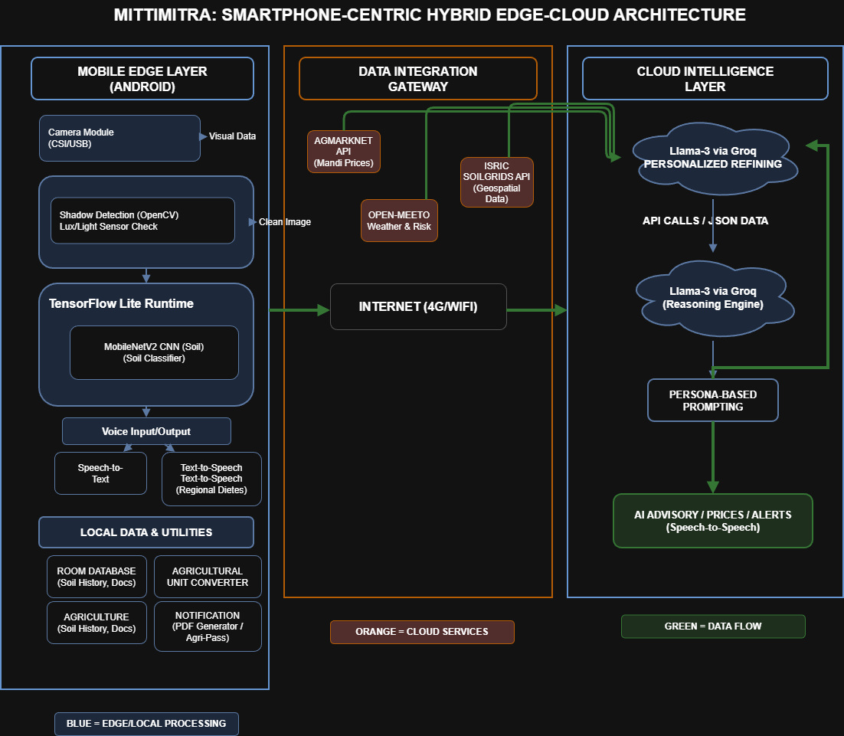

Design- Objective mapping :

The Guard Module in the Edge Layer achieves Design for Precision (Obj 1) by stopping the classification model from processing low-quality data.
Design for Accessibility (Obj 2 & 3): Made possible by the Cloud Intelligence and Interaction Loop, which transforms complicated information into straightforward, colloquial guidance.
Design for Reliability (Obj 5): Assisted by the Local Room Database, which stores crucial information to guarantee that the application continues to work in the event of a network outage.

Signature of the guide:

